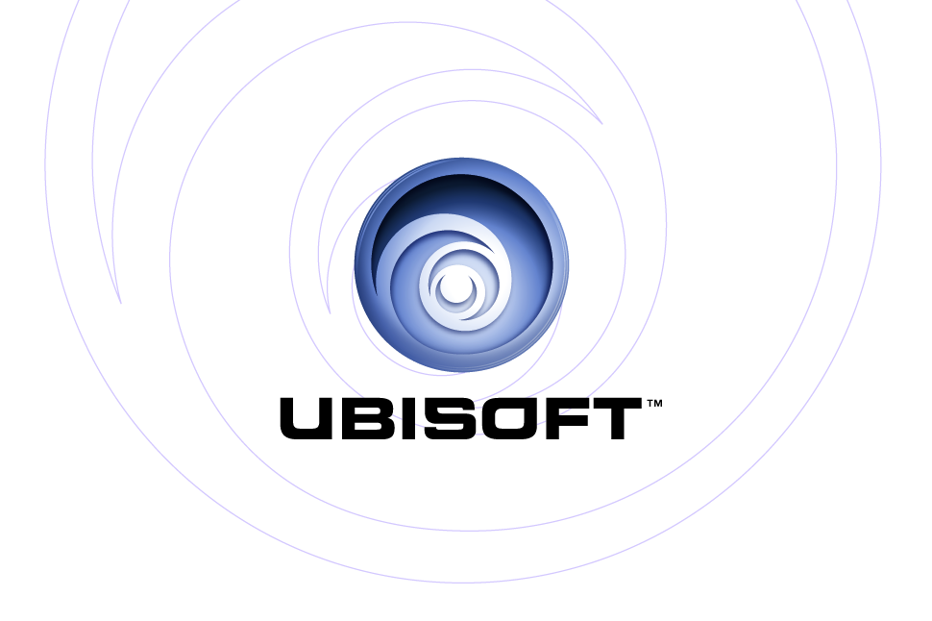

PRESENTS: | Xbox®
 | PlayStation®2

Far Cry: Instincts™

Product Description

After escorting an inquisitive journalist to a remote tropical island, Jack Carver finds himself stranded in paradise, hunted by an unrelenting team of highly trained mercenaries. Incorporating state-of-the-art graphic technology and a host of innovative FPS gameplay conventions, Far Cry redefines the term “survival action.” As Jack, you’ll have to outwit hordes of cunning mercenaries utilizing a variety of tactics. Make long-range assaults, set traps, commandeer vehicles – even develop new skills and abilities to outlast the island’s evils and escape with your life.

Key Features

- Survive by Any Means
Go it alone by setting traps, scouting ahead, sniping from afar, and commandeering all types of assault vehicles.

- Shoot to Kill
Finally, AI that’s actually intelligent. Featuring the all-new Full Action Response (FAR) system, enemies react in real time, take cover, call in reinforcements, and use advanced group-formation tactics to take you out.

- A Whole New World
Discover all-new locations including abandoned mines, aquatic labs, and a host of locations not found in the PC version.

- Wage War Online
Explosive Xbox Live™ play allows you to engage in island warfare in more than eight unique modes of multiplayer combat.

- Create a Slice of Paradise
Build your own multiplayer maps for use on Xbox Live or in split-screen mode. This first-of-its-kind editor for the Xbox console is ultra-powerful and specially designed for the Xbox Controller and allows gamers to switch from editing to playing on the fly.

Product Specifications:
Publisher: Ubisoft
Developer: Ubisoft’s Montreal Studio
Ship Date: Q1 2005
Category: First-Person Action Shooter
ESRB: Rating Pending

